How to Use XAMPP to Run Your Own Web Server

**Installing XAMPP**

Follow these steps for installing XAMPP:

Download link - <https://www.apachefriends.org/download.html>

**Step 1:** Disable your anti-virus as it can cause some XAMPP components to behave erratically.

**Step 2**: Disable User Account Control (UAC). UAC limits write permissions to XAMPP’s default installation directory (c:/Program Files/xampp), forcing you to install in a separate directory. You can learn how to disable UAC here. (Optional)

**Step 3:** Start the installation process by double-clicking on the XAMPP installer. Click ‘Next’ after the splash screen.

**Step 4**: Here, you can select the components you want to install. Choose the default selection and click ‘Next’.

**Step 5**: Choose the folder you want to install XAMPP in. This folder will hold all your web application files, so make sure to select a drive that has plenty of space.

**Step 6:** The next screen is a promo for BitNami, an app store for server software. Deselect the ‘Learn more about BitNami for XAMPP’ checkbox, unless you actually enjoy receiving promo mails!

**Step 7:** Setup is now ready to install XAMPP. Click Next and wait for the installer to unpack and install selected components. This may take a few minutes. You may be asked to approve Firewall access to certain components (such as Apache) during the installation process.

**Step 8:** Installation is now complete! Select the ‘Do you want to start the Control Panel now?’ checkbox to open the XAMPP control panel.

## Testing Your XAMPP Installation

**Double-click on the new XAMPP Control Desktop shortcut or Use the Search feature in Windows 10 to find the XAMPP Control App, which opens up the XAMPP Control Panel Application. There you will see a column of "Start" buttons. Select the ones for MySQL and for Apache...you should now see a green "Running" indicator**

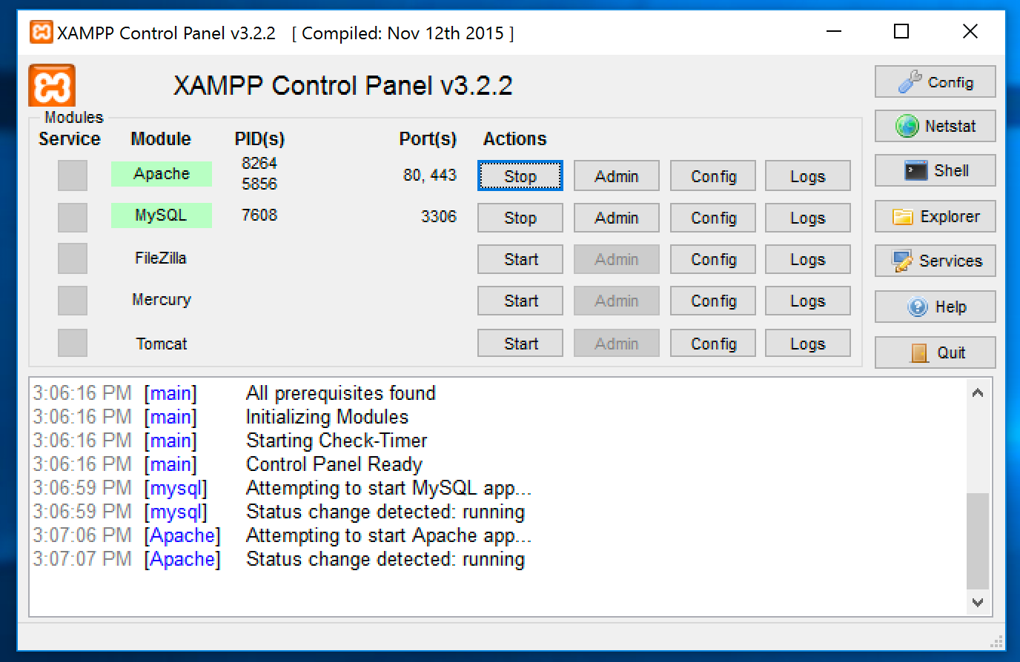

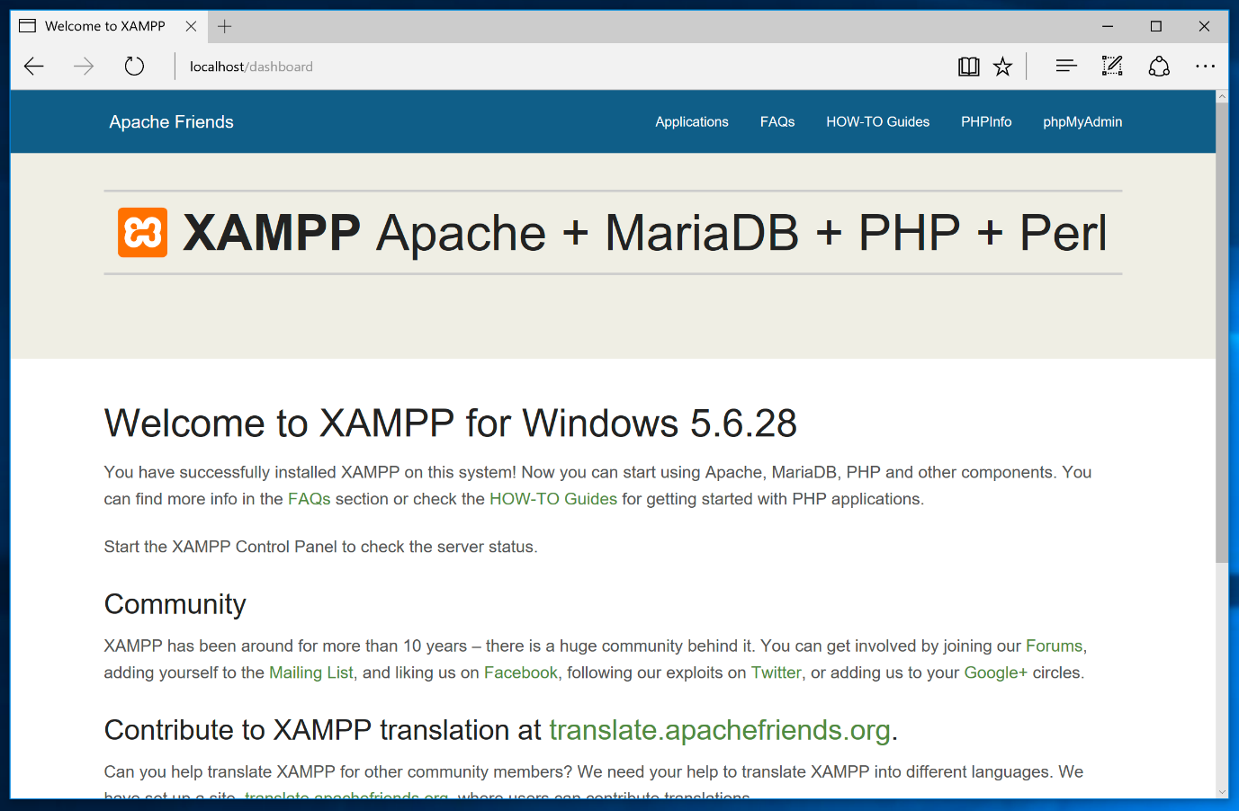

**PROJECT WEBPAGE & FOLDER**

## Putting Stuff in Web Folder

Under XAMPP root directory there is a folder called **htdocs**. That’s where you should put your web site related stuff.

**C:\xampp\htdocs\project**

In your web browser, go to <http://localhost/project/index.php> You should see the start page of PROJECT:



**PROJECT DATABASE**

## **How to Create a MySQL Database using XAMPP**

Many applications, such as Pretashop, Joomla!, Magento require an SQL database as part of their setup. With XAMPP installed, this is easy to do. Please the following steps:

**Step 1:** **Open** your browser and enter[**http://localhost/phpmyadmin**](http://localhost/phpmyadmin). This will bring you to the MySQL setup page:

**Step 2:** **Enter** a name for the database, then **click** on the **Create** button. The name must be 64 characters or less and composed of letters, numbers and underscores. Avoid using numbers at the start of the name. A good name should indicate the purpose of the database. For example: **your_database**

**Step 3:** **Ensure** the database was successfully created:

**Step 4:** **Create table or import database file using import option**

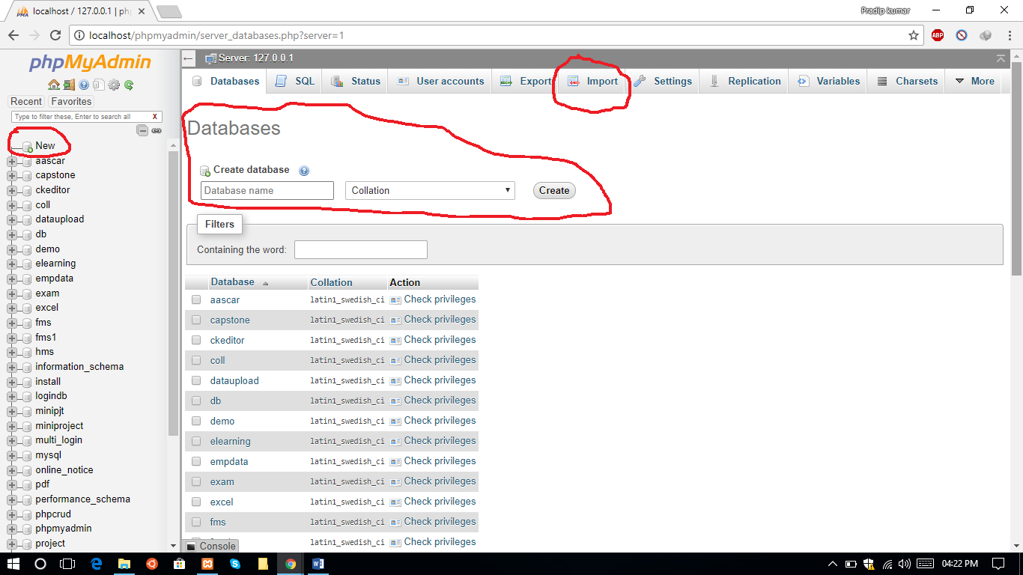

**VIEW DATABASE**

**Step 1:** **Open** your browser and enter[**http://localhost/phpmyadmin**](http://localhost/phpmyadmin). This will bring you to the MySQL setup page

**Step 2: Select** your database

